*PERSONAL PROFILE*

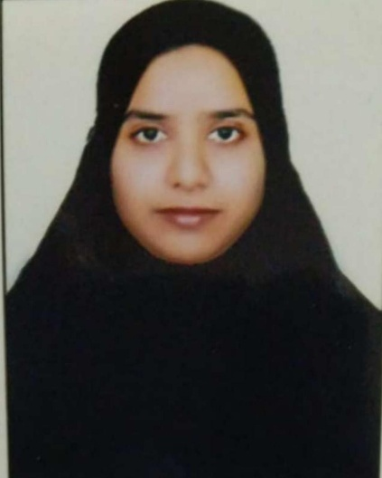

**Name: AFROZ BEGUM**

**Designation:Lecturer in Urdu**

College Address:SRR&CVRGovtDegreeCollege(A),Vijayawada

CellNo: 9492478084

Mail Id: afrozbegum2320@gmail.com

**Educational Qualifications**

|  |  |  |  |  |
| --- | --- | --- | --- | --- |
| **S.NO** | **COURSE** | **BOARD/**  **UNIVERSITY** | **YEAROF**  **PASS** | **PERCENTAGE** |
|  |  |  |  |  |
| 1 | S.S.C. | BOARDOF  SECONDARY  EDUCATION | 2002 | 61% |
| 2. | INTERMEDIATE | BOARDOF  INTERMEDIATE  EDUCATION | 2002-2005 | 61.1% |
| 3 | BA, | Maulana Azad National Urdu University | 2005-2009 | 58.5% |
| 4 | B.Ed. | SNBTM B,Ed college Realle, Guntur, Andhra Pradesh | 2009-2010 | 72.4/% |
| 5 | MA Urdu | Maulana Azad National Urdu University | 2010-2012 | 66.75% |
| 6 | (M,Ed) | (AL B,Ed College in Guntur) | (2022-2023) |  |

v

**Professional Experience:**

1.Worked as a School Vidhya valentari in Boys government high school in Guntur ,For a period of 1 year from 2012

2. Worked as a Lecturer in Urdu in Abhyudaya Mahila Kalasala degree college, in Guntur,Andhra Pradesh , for a period of 2 year from 2012-2014

3. Joined as a Lecturer in Urdu in SRR & CVR Government degree college in Vijayawada, Andhra Pradesh for a period of 5 year working from 12-08-2017 to till the date

Workshops attended:

International/National:

* Domestic Violence an International oneday workshop held on 2ndMarch 2020 at Government College For Women (A) Guntur, Andhra Pradesh
* Maulana Abdul Kalam Azaad National seminar at 11-11 2018 Maulana Azad Municipal Corporation high school, in Vijayawada,Andhra Pradesh